The title of this paper should be single spaced, Times New Roman, bold 14 point and left justified

First Author¹, Second Author² and Third Author³ (Times New Roman 12 pt left justified). Each name should have a superscript number to reference the author’s affiliation. Underline the presenting author.

¹ Affiliation of the first author, including Department/Institution, City and Country (12pt)
² Affiliation of the second author, including Department/Institution, City and Country (12pt)
³ Affiliation of the third author, including Department/Institution, City and Country (12pt), leave one blank line after author’s affiliations.

Your contribution must be submitted as a .pdf file. Use a 12 point Times New Roman typeface, and single spacing between lines. The paper format should be A4 (which will be reduced to A5 for printing). Document Margins should be 2.5 cm top and bottom, and 2 cm left and right. All contributions shall have a length of one page and must conform to these layout requirements.

Skip a line before each new paragraph, but do not indent paragraphs. Use left justified formatting for the text.

If you insert figures, ensure to include figure labels and scale markers on all figures. Captions should be placed below all figures and tables.

References should be included at the end of the text. Indicate references in the text with Arabic numbers in square brackets, preferably at the end of the sentence, before the period. Acknowledgments should be included in the last reference, which should be cited at the end of the last sentence of the text [4].

[1] F. Author et al., Conference Proceedings (year) p. 1.
[2] F. Author, S. Author and T.H. Author, Journal volume (year), p. 1.
[3] F. Author in “Introduction to abstract writing”, ed. D. Writers, (Publisher, City) p.1.
[4] The authors acknowledge funding from the United Federation of Planets, X File Department, Grant Number 42. Dr. W. Ho is thanked for his many useful discussions and contributions to this work.

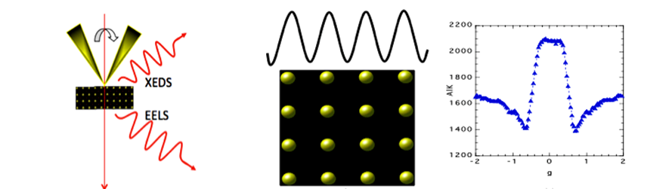

Figure 1. Times New Roman, 12 pt. Provide a short description of the figure, including labels and scale markers as appropriate.

